
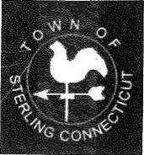
Voluntown/Sterling Transfer Station Commission Special Meeting
AGENDA
Ekonk Community Grange Hall, 723 Ekonk Hill Road, Sterling
August 6, 2025
7:00 PM

- Executive Session

  - Interviews for Transfer Station Supervisor

- New Business

  - Transfer Station Supervisor

- Adjournment

The next scheduled meeting will be held on September 24,2025.

